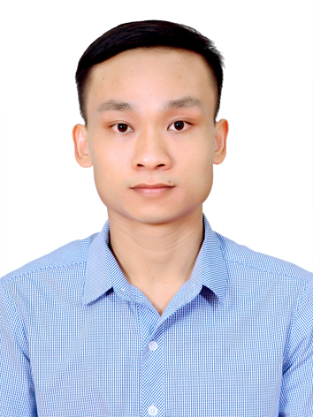
LE DUC HUY

Applying Position: IQC Engineer
CONTACT INFORMATION
Full name: Le Duc Huy
Date of birth: 18/09/1990
Sex: Male
ID card No: 031090010309
Address: Thien Kha, Tien Cuong, Tien Lang, Hai Phong
Mobile: 034.456.9966
Email: huy33391@gmail.com

CAREER OBJECTIVE
I am passionate about electric cars and quality control, and I want to contribute to VinFast's growth as a leading automotive brand. With my knowledge of quality management and attention to detail, I ensure that all incoming components meet VinFast’s high standards. I am excited to be part of the team and help maintain the quality of VinFast vehicles.
WORK EXPERIENCE
IQC staff
KYOCERA Document Technology Hai Phong (28/9/2021 to PRESENT)

- Make inspection guidelines based on drawings
- Train workers to perform inspections based on established guidelines
- Update inspection guidelines when issue happen
- Co-work with related team to find root cause and make corrective action for quality issues related component
- Performing other management tasks as required by my Team leader
- Program VBA, VB.net and UiPath to develop many software, macro, tool to reduce working time for Operator
IVI QA CS staff
LG Electronics Vietnam Haiphong (15/04/2018 to 27/09/2021)

- Coordinating cross functional teams (CFT) to handle quality issues at customer site
- 4M change management
- Program many macros, software to automatic some my jobs
- Report quality issues with my Team Leader weekly

Software Tester (QA staff)
CodeAndMore company (10/07/2013 to 14/04/2018)

- Review and clarify customer requirements
- Work closely with development team to develop, maintain and execute manual test cases
- Report, track, and monitor defects in the defect tracking system
- Update test documents (Test plan, test cases, test report)
- Estimate testing activities

EDUCATION
- 10/2008 – 05/2013 Vietnam Maritime University in Hai Phong City (Specialty: Naval Architect).

HONORS & AWARDS
- Scholarship in 1st semester 2010 – 2011.

PROFESSIONAL SKILLS
- I have 7 years’ experience about QC Engineer
- Working knowledge in APQP, PPAP, PFMEA, Control Plan, WI
- Able to use hand measurement tools (calipers, micro-meters…)
- Specialist in macro, VBA Excel programing
- Use UiPath to develop the automatic tool to reduce working time for Operator
- Use QC 7 Tools, FIFO, 5S, 5 Why, 8D report, Logic tree as well as technical skill on report, analysis, solve problem.
- Good command in English.
- Computer software very proficiency: MS Office, Internet.
- Able to read engineering drawings.
- Able to work independently and within a team under pressure.
- Quick-learner, self-confident and active.
- Hard working, well-organized and high sense of responsibility.
HOBBY
- I like jogging, workout with my friends.

